Redevco Acquires Sustainable Housing Development in Amstelveen from AM and Expands Residential Portfolio

Amsterdam, November 23, 2021 - Redevco, one of Europe’s largest privately-owned real estate investment managers, has expanded its residential portfolio through an agreement with Dutch developer AM to purchase 172 rental apartments with parking spaces, and a commercial unit, in Amstelveen in the southern Greater Amsterdam area. The ‘Hollandse Meesters’ project consists of two residential towers with 131 owner-occupied homes alongside the rental apartments and will arise on an attractive site where an office building is currently located. The development, designed to high sustainability levels, will be positioned in the mid-market rental segment where there is an acute shortage of available accommodation in the Amsterdam region.

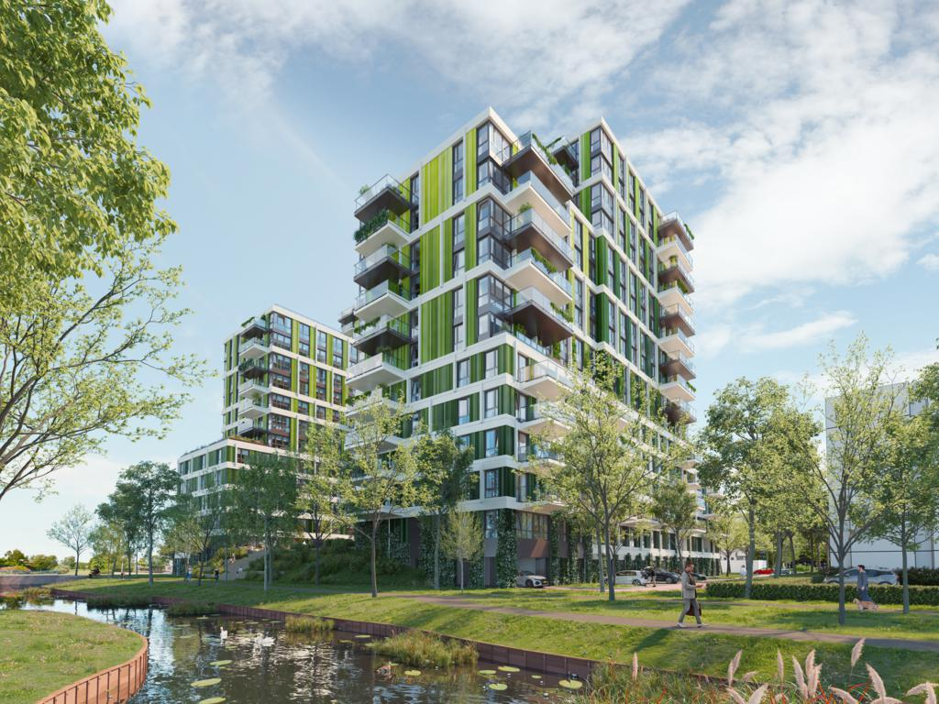
Artist impression Hollandse Meesters (visual : AM)

Robert Bakker, Development Manager at Redevco Netherlands, said: “This project further highlights our diversification strategy and focus on liveable and sustainable urban areas in Europe’s most attractive cities. Hollandse Meesters offers high-quality multifunctional rental apartments with amenities including a communal courtyard, roof terrace, and bike and car sharing facilities. It will give a former office location a new lease on life and create new sustainable homes in an area where there is a huge housing shortage.”

Peter Heuvelink, Director AM Noordwest, added: “Hollandse Meesters is an example of AM’s core focus on diverse neighbourhoods and good living through the development of homes in an attractive and liveable environment that remain affordable for local residents.”

Hollandse Meesters is located on the Mr. G. Groen van Prinstererlaan in the centre of Amstelveen and supports the municipality’s strategic plan to realise 10,000 new homes in the area in coming years. The project uses innovative solutions, such as heating and cooling storage technology, solar panels and water buffering on the roofs, to regulate the indoor climate. The building’s design is aimed at maximising natural light and air quality to promote a healthy environment and lifestyle. Residents will also have access to a shared mobility hub offering e-bikes, scooters and electric cars and can make use of a coffee bar, co-working spaces and a concierge service.

Hollandse Meesters will provide a total of 303 apartments including 172 rental apartments and 131 owner-occupied homes. The complex includes a co-living component, or so-called ‘Friends’ flats, named after the popular US television series where two people live together at a prime location in an affordable and attractive home. Both occupiers have their own bed- and bathrooms and share other facilities. Some 65% of the 303 apartments fall within the medium-priced rental and owner-occupier market segments.

Residential real estate has become a key focus for Redevco, which aims to grow its investment mandates and portfolio to €10 billion in assets under management by 2025, through investing in other property sectors beyond retail.

ENDS

About Redevco:
Redevco, part of COFRA Holding AG, is a real estate investment management company with a clear focus on vibrant places across Europe. As a partner in urban real estate we invest in properties with a view to developing future-proof buildings in dynamic urban locations where people want to live, work and play. Our specialist investment strategies, local real estate knowledge and the scale of our pan-European platform enable us to create value for both our investor clients and occupiers. Our highly experienced professionals purchase, develop, let and manage properties, ensuring that the portfolios optimally reflect the needs of our clients. We believe in long-term investments where quality and sustainability are key. We have nearly 300 assets under management with a total portfolio value of about €7.5 billion.

About AM
It is our passion to conceive and develop inspiring and sustainable living environments. Finding a solution to social challenges is central to the process of every development we undertake in our role as a responsible urban developer. The key themes we focus on are ‘Innovative in sustainability’, ‘Diversity in cities’, ‘Healthy urban living & working’, ‘City and urban developer’, and ‘God living’. Through cooperation with governments, real estate investors, housing corporations, social organisations, tenants and other users, we create distinctive, high-quality environments to live, work, shop and recreate. AM, part of Royal BAM Group, thus ensures quality of space and life. See also www.am.nl.

For further information please contact:
Priscilla Tomasoa
Head of PR & Corporate Communications
Redevco B.V.
Wibautstraat 224
1097 DN Amsterdam, Nederland
Tel .: +31 20 599 6262
E-mail: priscilla.tomasoa@redevco.com
Website: www.redevco.com

AM
Department in- and external communications, telephone 030-6097222 or communicatie@am.nl. Also have a look at: www.am.nl. High Res illustrations can be downloaded on www.am.nl/actueel.

